Name: Rakshith N

Usn no:1NT19IS126

C1 Batch

EXERCISE 5

Queries

1. Insert 5 records using Insert command in HiveQL



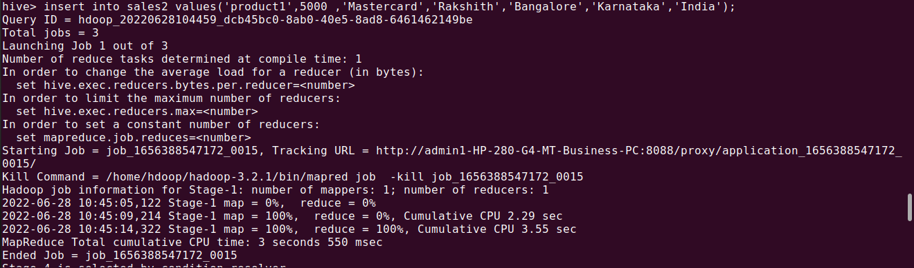

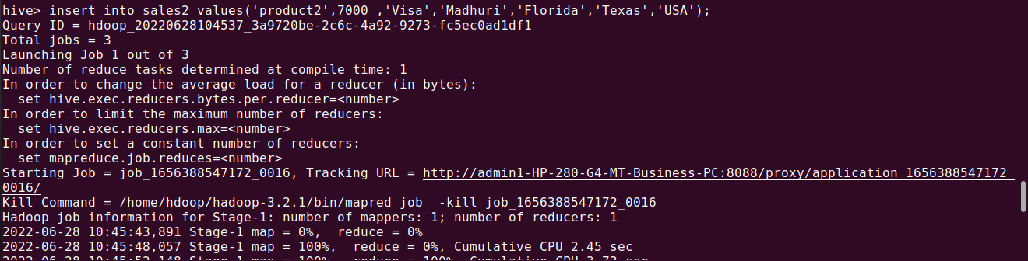

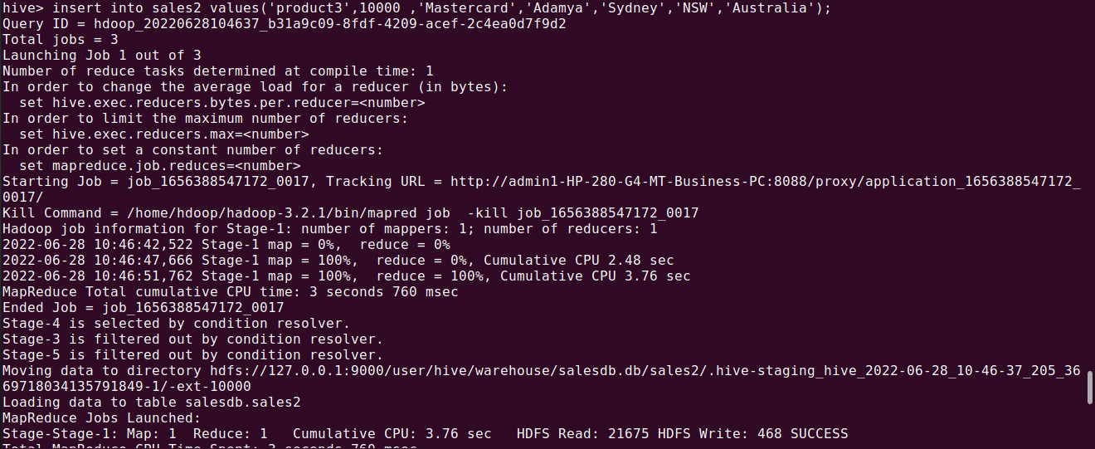

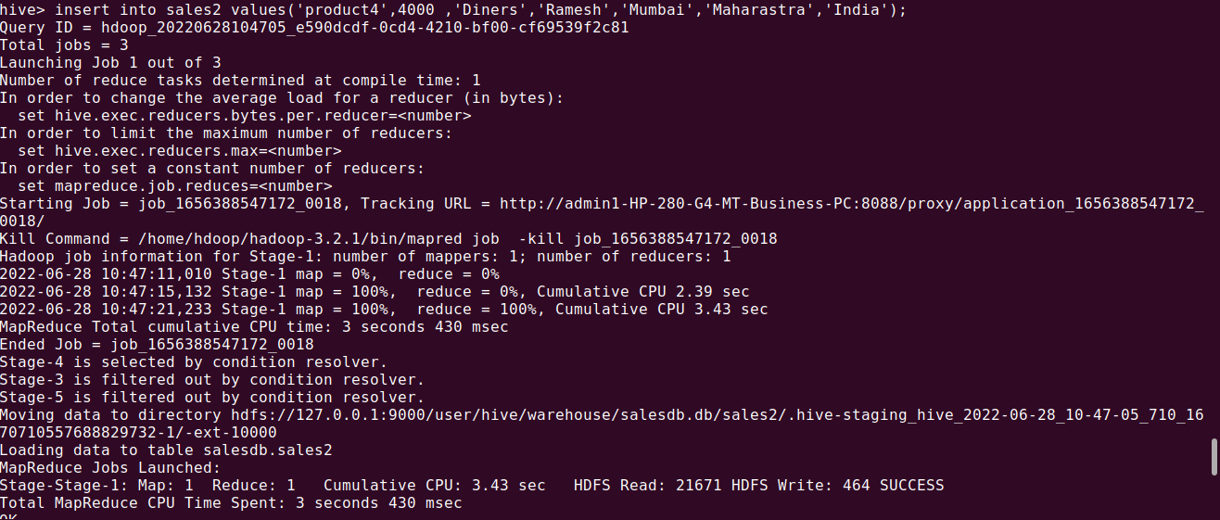

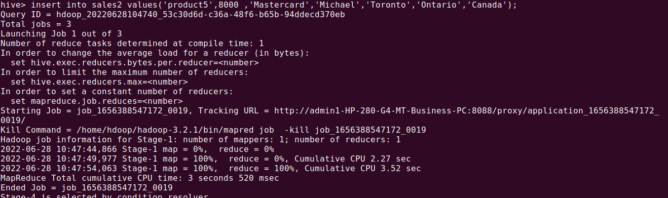

2. Import the dataset from the sales.csv file.

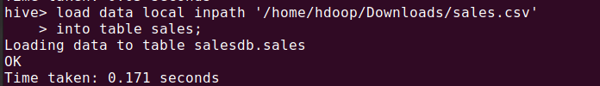

3. Count the number of sales done by each country

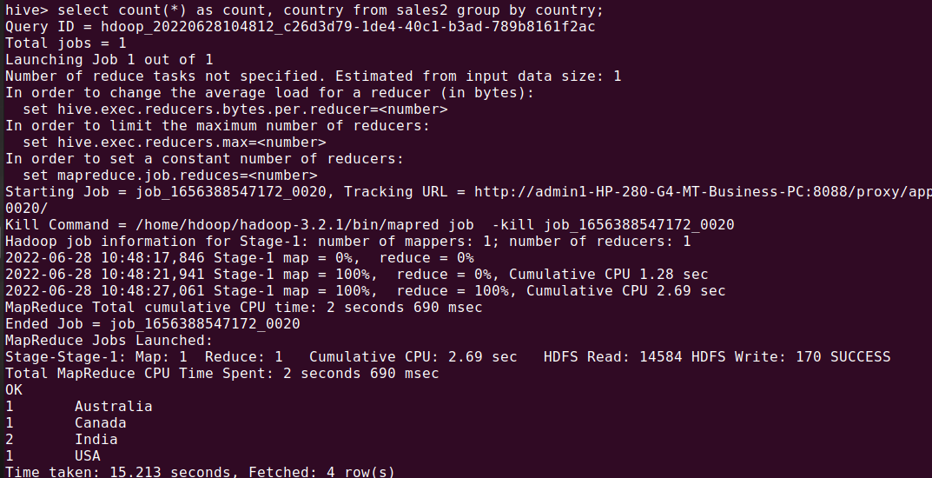

4. Count the number of sales done by each state

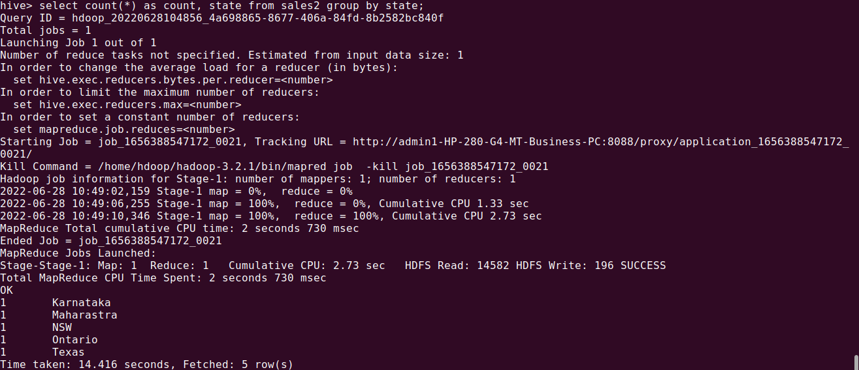

5. Display (Product, name) grouped by product,name.

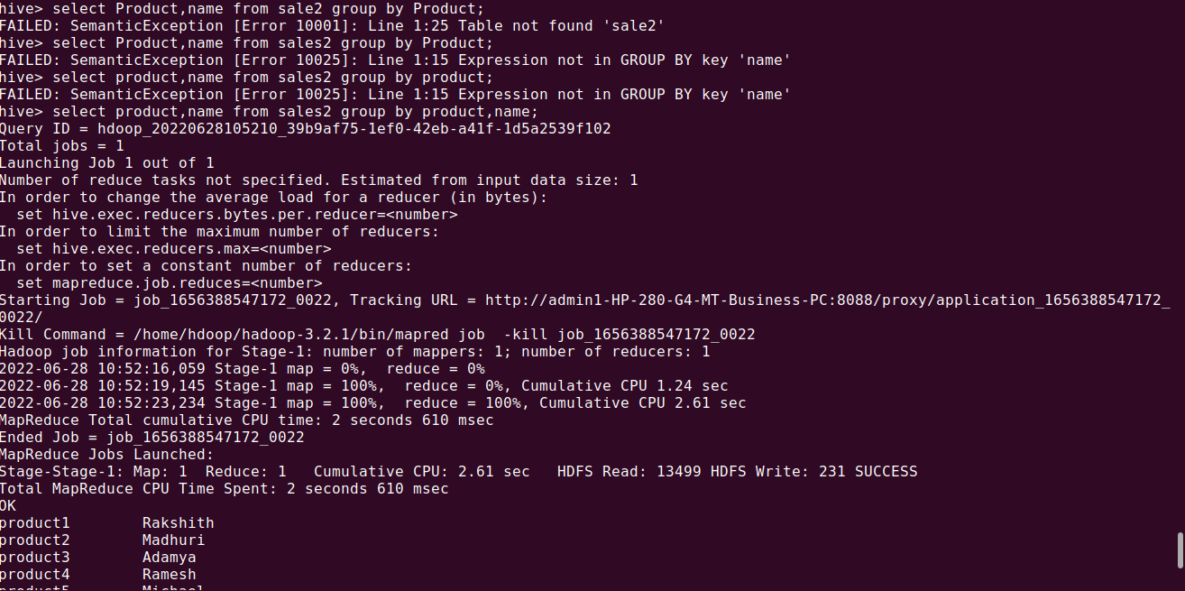

6. Create separate views for VISA and Mastercard

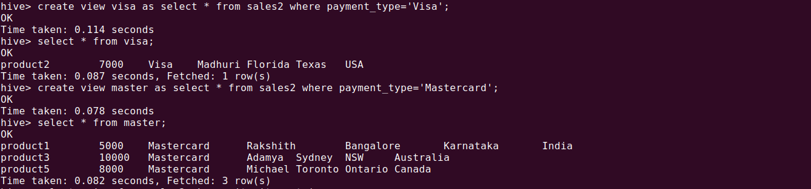

7. Show all the transactions done in Toronto



8. Find the max price of transactions done within the country of India.

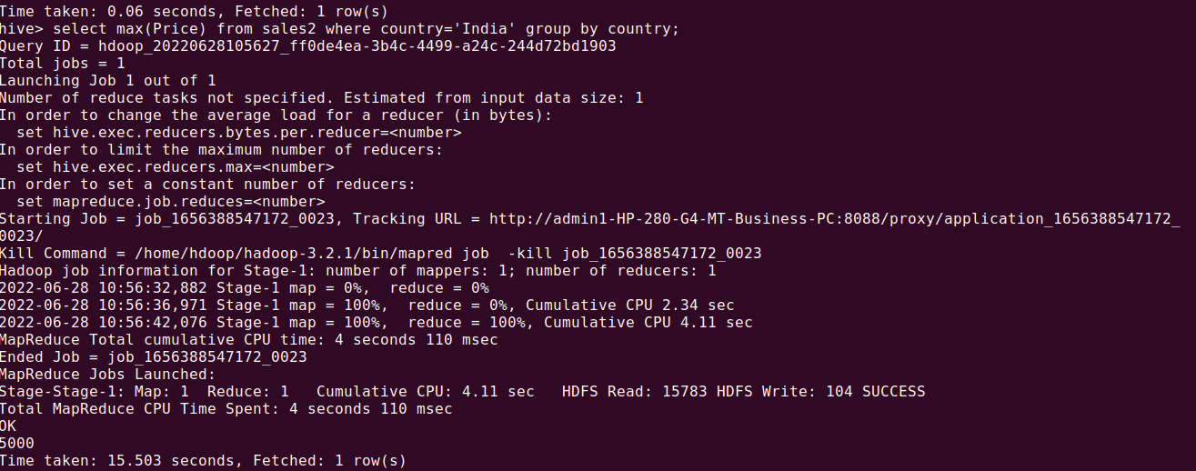

9. Find the number of transactions whose price is in between 5000-10000

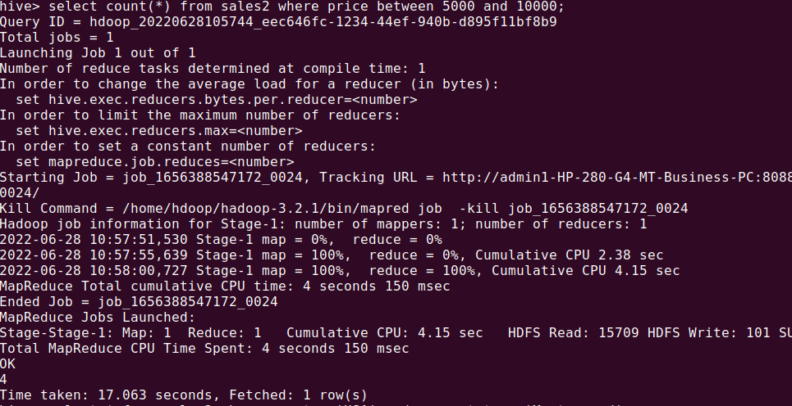

10. List all the transactions done in the India using Mastercard

